Pg. 119 – 127, Java Programming *A comprehensive Introduction*

Class and Object expanded

**Due Monday 3/10/14 during lab**

**Section 1: Define / Answer**

“programmer created” class- A class is the blueprint from which individual objects are created.

“programmer created” object- member you created in class

“programmer created” method-collection of statements that are grouped together to perform an operation; use to access the static field

*dot.operator-* *Dot operator is used to access methods and variables within objects and classes. They are used to access instance members of an object and class members of a class*

Discribe the purpose of the following statement inrefernce to a “programmer created object”

Vehicle minivan = **new** Vehicle();

creating a vehicle object

void method- a method in java is a sub-routine. The program executes linearly downwards through a list of instructions and when it encounters a method, execution branches and returns to the line following the method call. If the method was supposed to return something, it would have been defined as such, for instance return a value of double, or String. If no value is expected, the method is defined as 'void'.

Pg. 123, Java Programming *A comprehensive Introduction*

**Programming Assignment**

Task 1- Create a computer program that will calculate the range for 3 different vehicles.

The program should create a “programmer created” class, where 3 **int** **objects** are created passengers, fuel capacity, mpg.

Create a **void()** method inside the “programmer created “ class to calculate vehicle range**.**

**range =** **fuel capacity * miles per gallon**.

Each Vehicle type should have unique values for number of passengers, fuel capacity, and miles per gallon.

Follow the sample below and return information on 3 vehicle types.

**Sample Output: // Create similar output for 3 Vehicle Types**

The minivan carries= 7

The minivan has a fuel capacity of = 16

The minivan mpg = 21

The minivan has a range of: 336 miles

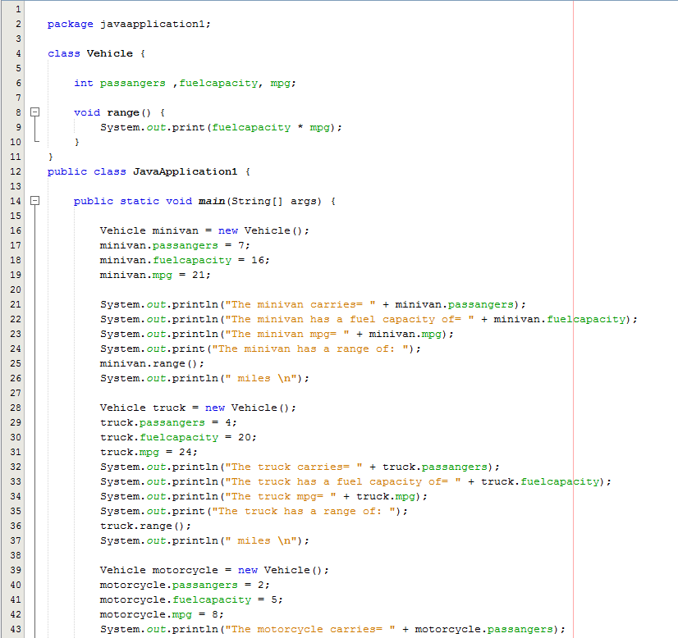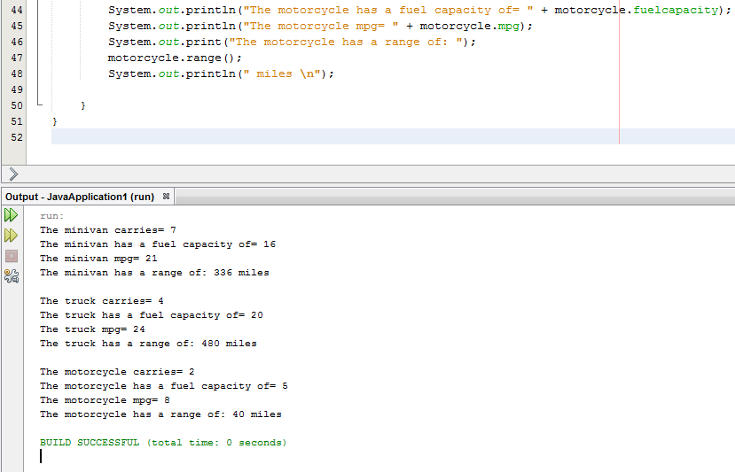

Pg. 151, Java Programming *A comprehensive Introduction*

*#13* Modified Version

Task 2- Create a **Die** “programmer created” class. Inside the “programmer created class” create 2 instance variables, each instance variable will be an integer type.

Create a void method that returns the value of a die roll. (random number between 1-6)

Create a void method the returns the value of two dice being rolled.

All calculations and integer assignment will take place in the “programmer created” class. **main** in your program will only operate the execution of the program.

Output will be the value of one random die roll and then the value of 2 random dice being rolled.

**Sample Output**

1 die Roll = 5

2 dice Roll = 7

**Example of main in the program.//**main only contains calls to methods/objects created in the “programmer created” class

public class DieRollClassDemo {

public static void main(String[] args) {

Die rollingdice = new Die();

rollingdice.dieroll();

rollingdice.diceroll();

